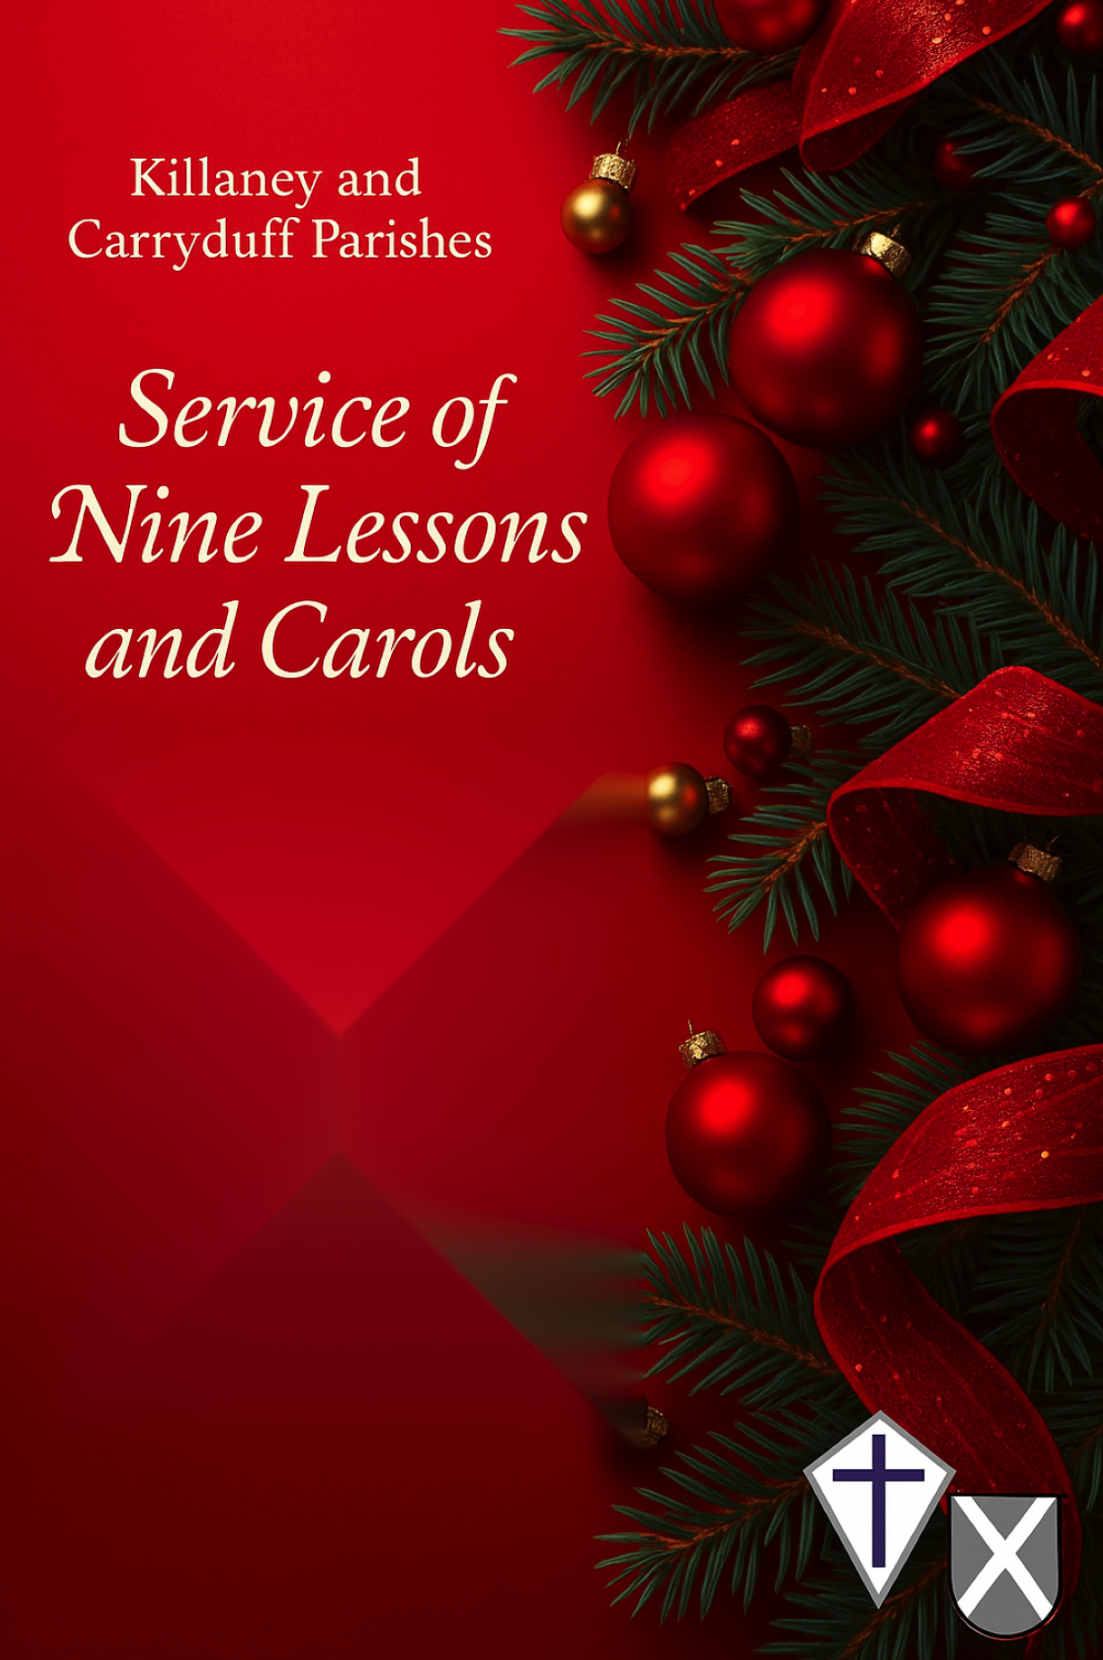Once in royal David’s city vs 1,2,5,6 - Hymn 177
(Please stand)

1 Once in royal David’s city stood a lowly cattle shed,
where a mother laid her baby in a manger for his bed;
Mary was that mother mild, Jesus Christ her little child.

2 He came down to earth from heaven who is God and Lord of all,
and his shelter was a stable, and his cradle was a stall;
with the poor and mean and lowly lived on earth our Saviour holy.

3 And our eyes at last shall see him, through his own redeeming love,
for that child so dear and gentle is our Lord in heaven above;
and he leads his children on to the place where he is gone.

4 Not in that poor lowly stable, with the oxen standing by,
we shall see him; but in heaven, set at God’s right hand on high;
when like stars his children crowned all in white shall wait around.

Greeting and Introduction

The Lord’s Prayer
Our Father, who art in heaven, hallowed be thy name,
thy kingdom come, thy will be done, on earth as it is in heaven.
Give us this day our daily bread.
And forgive us our trespasses as we forgive those who trespass against us.
And lead us not into temptation, but deliver us from evil.
For thine is the kingdom, the power, and the glory,
for ever and ever. Amen.

Genesis 1.26-2.3: The Image of God
Representing St Andrew's Select Vestry - Colin Mc Clintock

Then God said, ‘Let us make mankind in our image, in our likeness, so that they may rule over the fish in the sea and the birds in the sky, over the livestock and all the wild animals, and over all the creatures that move along the ground.’ So God created mankind in his own image, in the image of God he created them; male and female he created them. God blessed them and said to them, ‘Be fruitful and increase in number; fill the earth and subdue it. Rule over the fish in the sea and the birds in the sky and over every living creature that moves on the ground.’ Then God said, ‘I give you every seed-bearing plant on the face of the whole earth and every tree that has fruit with seed in it. They will be yours for food. And to all the beasts of the earth and all the birds in the sky and all the creatures that move along the ground—everything that has the breath of life in it—I give every green plant for food.’ And it was so. God saw all that he had made, and it was very good. And there was evening, and there was morning—the sixth day. Thus the heavens and the earth were completed in all their vast array. By the seventh day God had finished the work he had been doing; so on the seventh day he rested from all his work. Then God blessed the seventh day and made it holy, because on it he rested from all the work of creating that he had done.
Thanks be to God

Choir: Born in the night
Hymn 150 - Please remain seated
1 Born in the night, Mary's Child, a long way from your home;
coming in need, Mary's Child, born in a borrowed room.

2 Clear shining Light, Mary's Child, your face lights up our way;
Light of the world, Mary's Child, dawn on our darkened day.

3 Truth of our life, Mary's Child, you tell us God is good;
prove it is true, Mary's Child, go to your cross of wood.

4 Hope of the world, Mary's Child, you're coming soon to reign;
King of the earth, Mary's Child, walk in our streets again.

Isaiah 9.2,6,7: - The Coming King
Representing St Ignatius Select Vestry -Sandra Thomas

The people walking in darkness have seen a great light; on those living in the land of deep darkness a light has dawned.
For to us a child is born, to us a son is given, and the government will be on his shoulders. And he will be called Wonderful Counsellor, Mighty God, Everlasting Father, Prince of Peace.
Of the greatness of his government and peace there will be no end. He will reign on David’s throne and over his kingdom, establishing and upholding it with justice and righteousness from that time on and for ever.
The zeal of the LORD Almighty will accomplish this.
Thanks be to God

The people that in darkness walked - Hymn 199
1 The people that in darkness walked a glorious light have seen;
the light has shined on them who long in shades of death have been.

2 To hail thee, Sun of Righteousness, the gathering nations come;
they joy as when the reapers bear their harvest treasures home.

3 For unto us a Child is born, to us a Son is given,
and on his shoulder ever rests all power in earth and heaven.

4 His name shall be the Prince of Peace, for evermore adored
the Wonderful, the Counsellor, the Everlasting Lord.

5 His power, increasing, still shall spread, his reign no end shall know:
justice shall guard his throne above, and peace abound below.

Micah 5.2-4: - God Promises a Ruler
Representing St Ignatius Sunday Club - Rachel Morrison

But you, Bethlehem Ephrathah, though you are small among the clans of Judah, out of you will come for me one who will be ruler over Israel, whose origins are from of old, from ancient times.’ Therefore Israel will be abandoned until the time when she who is in labour bears a son, and the rest of his brothers return to join the Israelites. He will stand and shepherd his flock in the strength of the LORD, in the majesty of the name of the LORD his God. And they will live securely, for then his greatness will reach to the ends of the earth.
Thanks be to God

O little town of Bethlehem - Hymn 174:

O little town of Bethlehem, how still we see thee lie!
Above thy deep and dreamless sleep the silent stars go by;
yet in thy dark streets shineth ͜the everlasting Light;
the hopes and fears of all the years are met in thee tonight.

2 O morning stars, together ͜ proclaim the holy birth,
and praises sing to God the King, and peace to all on earth;
For Christ is born of Mary; and, gathered all above,
while mortals sleep, the angels keep ͜their watch of wondering love.

3 How silently, how silently, the wondrous gift is given!
So God imparts to human hearts the blessings of his heaven.
No ear may hear his coming; but in this world of sin,
where meek souls will receive him, still ͜ the dear Christ enters in.

4 O holy child of Bethlehem, descend to us, we pray;
cast out our sin, and enter in, be born in us today.
We hear the Christmas angels the great glad tidings tell:
O come to us, abide with us, our Lord, Emmanuel.

Luke 1.26-33,38: - The Angel Comes to Mary
Representing St Andrew's Sunday Club - Amanda Cousins

In the sixth month of Elizabeth’s pregnancy, God sent the angel Gabriel to Nazareth, a town in Galilee, to a virgin pledged to be married to a man named Joseph, a descendant of David. The virgin’s name was Mary. The angel went to her and said, ‘Greetings, you who are highly favoured! The Lord is with you.’ Mary was greatly troubled at his words and wondered what kind of greeting this might be. But the angel said to her, ‘Do not be afraid, Mary, you have found favour with God. You will conceive and give birth to a son, and you are to call him Jesus. He will be great and will be called the Son of the Most High. The Lord God will give him the throne of his father David, and he will reign over Jacob’s descendants for ever; his kingdom will never end.’ ‘I am the Lord’s servant,’ Mary answered. ‘May your word to me be fulfilled.’ Then the angel left her.
Thanks be to God

The angel Gabriel - Hymn 139

1 The angel Gabriel from heaven came,
his wings as drifted snow, his eyes as flame;
"All hail," said he, "thou lowly maiden Mary,
most highly favoured lady," Gloria!

2 "For known a blessed Mother thou shalt be,
all generations laud and honour thee,
thy Son shall be Emmanuel, by seers foretold,
most highly favoured lady," Gloria!

3 Then gentle Mary meekly bowed her head,
"To me be as it pleaseth God," she said,
"my soul shall laud and magnify his holy Name."
Most highly favoured lady, Gloria!

4 Of her, Emmanuel, the Christ,
was born in Bethlehem, all on a Christmas morn,
and Christian folk throughout the world will ever say--
"Most highly favoured lady," Gloria!

Matthew 1.18-25: God’s Purpose is Explained to Joseph
Representing K & C parish readers -Raymond Scott

This is how the birth of Jesus the Messiah came about: his mother Mary was pledged to be married to Joseph, but before they came together, she was found to be pregnant through the Holy Spirit. Because Joseph her husband was faithful to the law, and yet did not want to expose her to public disgrace, he had in mind to divorce her quietly. But after he had considered this, an angel of the Lord appeared to him in a dream and said, ‘Joseph son of David, do not be afraid to take Mary home as your wife, because what is conceived in her is from the Holy Spirit. She will give birth to a son, and you are to give him the name Jesus, because he will save his people from their sins.’ All this took place to fulfil what the Lord had said through the prophet: ‘The virgin will conceive and give birth to a son, and they will call him Immanuel’ (which means ‘God with us’). When Joseph woke up, he did what the angel of the Lord had commanded him and took Mary home as his wife. But he did not consummate their marriage until she gave birth to a son. And he gave him the name Jesus.
Thanks be to God

Choir: Away in a Manger - Hymn 149
(Please sit for v1 and then stand and join in from v2)

1 Away in a manger, no crib for a bed,
the little Lord Jesus laid down his sweet head;
the stars in the bright sky looked down where he lay,
the little Lord Jesus asleep on the hay.

2 The cattle are lowing, the baby awakes,
but little Lord Jesus, no crying he makes.
I love thee, Lord Jesus; look down from on high,
and stay by my side until morning is nigh.

3 Be near me, Lord Jesus; I ask thee to stay
close by me for ever, and love me, I pray.
Bless all the dear children in thy tender care,
and fit us for heaven, to live with thee there.

Luke 2.1-7: Jesus is Born
Representing K & C Music - Helen Mulholland

In those days Caesar Augustus issued a decree that a census should be taken of the entire Roman world. (This was the first census that took place while Quirinius was governor of Syria.) And everyone went to their own town to register. So Joseph also went up from the town of Nazareth in Galilee to Judea, to Bethlehem the town of David, because he belonged to the house and line of David. He went there to register with Mary, who was pledged to be married to him and was expecting a child. While they were there, the time came for the baby to be born, and she gave birth to her firstborn, a son. She wrapped him in cloths and placed him in a manger, because there was no guest room available for them.
Thanks be to God

Joy to the world - Hymn 166

Joy to the world, the Lord is come!
Let earth receive her King; Let ev’ry heart prepare him room,
and heav’n and nature sing, and heav’n and nature sing,
and heav’n, and heav’n and nature sing.

2 Joy to the world, the Saviour reigns!
Let all their songs employ; while fields and floods, rocks, hills and plains
repeat the sounding joy, repeat the sounding joy,
repeat, repeat the sounding joy.

3 He rules the world with truth and grace,
and makes the nations prove the glories of his righteousness
and wonders of his love, and wonders of his love,
and wonders, wonders of his love.

Luke 2:8-20: The Shepherds go to the Manger
Representing St Ignatius Church Wardens - Joan Clayton

And there were shepherds living out in the fields near by, keeping watch over their flocks at night. An angel of the Lord appeared to them, and the glory of the Lord shone around them, and they were terrified. But the angel said to them, ‘Do not be afraid. I bring you good news that will cause great joy for all the people. Today in the town of David a Saviour has been born to you; he is the Messiah, the Lord. This will be a sign to you: you will find a baby wrapped in cloths and lying in a manger.’ Suddenly a great company of the heavenly host appeared with the angel, praising God and saying, ‘Glory to God in the highest heaven, and on earth peace to those on whom his favour rests.’ When the angels had left them and gone into heaven, the shepherds said to one another, ‘Let’s go to Bethlehem and see this thing that has happened, which the Lord has told us about.’ So they hurried off and found Mary and Joseph, and the baby, who was lying in the manger. When they had seen him, they spread the word concerning what had been told them about this child, and all who heard it were amazed at what the shepherds said to them. But Mary treasured up all these things and pondered them in her heart. The shepherds returned, glorifying and praising God for all the things they had heard and seen, which were just as they had been told.
Thanks be to God

In the bleak midwinter: verses 1,2,4 & 5
Offering Hymn 162

1 In the bleak midwinter frosty wind made moan,
earth stood hard as iron, water like a stone:
snow had fallen, snow on snow, snow on snow,
in the bleak midwinter, long ago.

2 Our God, heaven cannot hold him,
nor earth sustain; heav'n and earth shall flee away when he comes to reign:
in the bleak midwinter a stable place sufficed
the Lord God Almighty, Jesus Christ.

4 Angels and archangels may have gathered there,
cherubim and seraphim thronged the air,
but his mother only, in her maiden bliss,
worshipped the beloved with a kiss.

5 What can I give him, poor as I am?
If I were a shepherd, I would bring a lamb,
if I were a wise man I would do my part,
yet what I can I give him, give my heart.

Matthew 2.1-12: Travellers Come from the East
Representing St Andrew's Church Wardens - Adrian Cousins

After Jesus was born in Bethlehem in Judea, during the time of King Herod, Magi from the east came to Jerusalem and asked, ‘Where is the one who has been born king of the Jews? We saw his star when it rose and have come to worship him.’ When King Herod heard this he was disturbed, and all Jerusalem with him. When he had called together all the people’s chief priests and teachers of the law, he asked them where the Messiah was to be born. ‘In Bethlehem in Judea,’ they replied, ‘for this is what the prophet has written: ‘ “But you, Bethlehem, in the land of Judah, are by no means least among the rulers of Judah; for out of you will come a ruler who will shepherd my people Israel.”’ Then Herod called the Magi secretly and found out from them the exact time the star had appeared. He sent them to Bethlehem and said, ‘Go and search carefully for the child. As soon as you find him, report to me, so that I too may go and worship him.’ After they had heard the king, they went on their way, and the star they had seen when it rose went ahead of them until it stopped over the place where the child was. When they saw the star, they were overjoyed. On coming to the house, they saw the child with his mother Mary, and they bowed down and worshipped him. Then they opened their treasures and presented him with gifts of gold, frankincense and myrrh. And having been warned in a dream not to go back to Herod, they returned to their country by another route.
Thanks be to God

Choir: Thou didst leave thy throne - Hymn 114 vs 1, 2 &5
(Please remain seated)

Thou didst leave thy throne and thy kingly crown
when thou camest to earth for me; but in Bethlehem's home
was there found no room for thy holy nativity:

O come to my heart, Lord Jesus; there is room in my heart for thee.

2 Heaven's arches rang when the angels sang,
to proclaim thy royal degree; yet in lowly birth didst
thou come to earth, and in deepest humility:

O come to my heart, Lord Jesus; there is room in my heart for thee.

5 When the heav'ns shall ring, and the angels sing,
at thy coming to victory, let thy voice call me home,
saying, "Yet there is room, there is room at my side for thee.

O come to my heart, Lord Jesus; there is room in my heart for thee.

John 1:1-14: The Word Becomes Flesh
(Please remain standing)
K & C Diocesan Lay reader - Marlene Moore

In the beginning was the Word, and the Word was with God, and the Word was God. He was with God in the beginning.
Through him all things were made; without him nothing was made that has been made. In him was life, and that life was the light of all mankind.
The light shines in the darkness, and the darkness has not overcome it.
There was a man sent from God whose name was John. He came as a witness to testify concerning that light, so that through him all might believe. He himself was not the light; he came only as a witness to the light. The true light that gives light to everyone was coming into the world. He was in the world, and though the world was made through him, the world did not recognise him. He came to that which was his own, but his own did not receive him. Yet to all who did receive him, to those who believed in his name, he gave the right to become children of God - children born not of natural descent, nor of human decision or a husband’s will, but born of God. The Word became flesh and made his dwelling among us. We have seen his glory, the glory of the one and only Son, who came from the Father, full of grace and truth.
Thanks be to God

The Collect for Christmas Eve

The Blessing

Hark! the herald-angels sing - Hymn 160:

Hark! the herald-angels sing glory to the new-born King,
peace on earth, and mercy mild, God and sinners reconciled.
Joyful, all you nations, rise, join the triumph of the skies;
with the angelic host proclaim, ‘Christ is born in Bethlehem’:

Hark! the herald-angels sing glory to the new-born King.

2 Christ, by highest heaven adored, Christ, the everlasting Lord;
late in time behold him come, offspring of a virgin’s womb.
veiled in flesh the Godhead see, hail the incarnate Deity!
Pleased as man with us to dwell, Jesus, our Emmanuel:

Hark! the herald-angels sing glory to the new-born King.

3 Hail, the heaven-born Prince of peace! Hail, the Sun of righteousness!
Light and life to all he brings, risen with healing in his wings:
mild he lays his glory by, born that we no more may die;
born to raise each child of earth, born to give us second birth:

Hark! the herald-angels sing glory to the new-born King.

Dismissal:

Father of all, you have given us your Son to be the Saviour of the world.
Welcome us, your children, into your kingdom to enjoy your presence forever. Amen.

Refreshments will be served in the hall: everyone is welcome

