You are very welcome to St Andrew’s for our service of Lights and Carols

Opening Prayer

Away in a manger - Hymn 149

1 Away in a manger,  no crib for a bed,  the little Lord Jesus  laid down his sweet head;  the stars in the bright sky  looked down where he lay,  the little Lord Jesus  asleep on the hay.  2 The cattle are lowing,  the baby awakes,  but little Lord Jesus,  no crying he makes.  I love you, Lord Jesus;  look down from on high,  and stay by my side  until morning is nigh. | 3 Be near me, Lord Jesus;  I ask you to stay  close by me for ever,  and love me, I pray.  Bless all the dear children  in your tender care,  and fit us for heaven,  to live with you there.  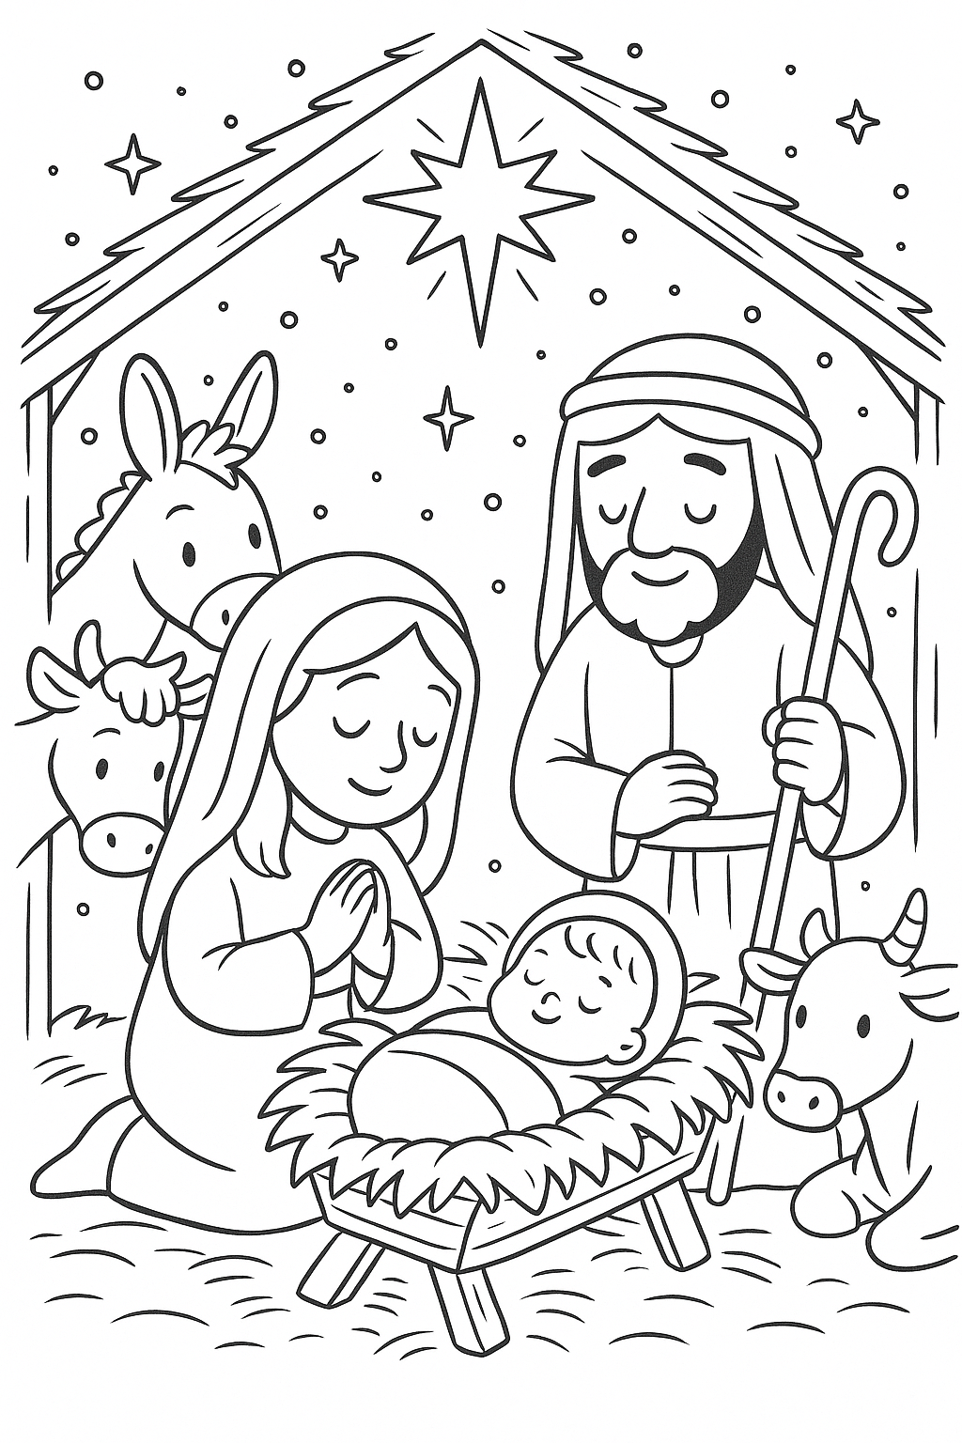

Luke 2:1-20
The reading is from Luke Chapter 2 beginning at verse 1

The Birth of Jesus
2 In those days Caesar Augustus issued a decree that a census should be taken of the entire Roman world. 2 (This was the first census that took place while Quirinius was governor of Syria.) 3 And everyone went to their own town to register. 4 So Joseph also went up from the town of Nazareth in Galilee to Judea, to Bethlehem the town of David, because he belonged to the house and line of David. 5 He went there to register with Mary, who was pledged to be married to him and was expecting a child. 6 While they were there, the time came for the baby to be born, 7 and she gave birth to her firstborn, a son. She wrapped him in cloths and placed him in a manger, because there was no guest room available for them.8 And there were shepherds living out in the fields nearby, keeping watch over their flocks at night. 9 An angel of the Lord appeared to them, and the glory of the Lord shone around them, and they were terrified. 10 But the angel said to them, “Do not be afraid. I bring you good news that will cause great joy for all the people. 11 Today in the town of David a Savior has been born to you; he is the Messiah, the Lord. 12 This will be a sign to you: You will find a baby wrapped in cloths and lying in a manger.” 13 Suddenly a great company of the heavenly host appeared with the angel, praising God and saying, 14 “Glory to God in the highest heaven, and on earth peace to those on whom his favour rests.”15 When the angels had left them and gone into heaven, the shepherds said to one another, “Let’s go to Bethlehem and see this thing that has happened, which the Lord has told us about.”16 So they hurried off and found Mary and Joseph, and the baby, who was lying in the manger. 17 When they had seen him, they spread the word concerning what had been told them about this child, 18 and all who heard it were amazed at what the shepherds said to them. 19 But Mary treasured up all these things and pondered them in her heart. 20 The shepherds returned, glorifying and praising God for all the things they had heard and seen, which were just as they had been told.

Silent night, holy night - Hymn 182
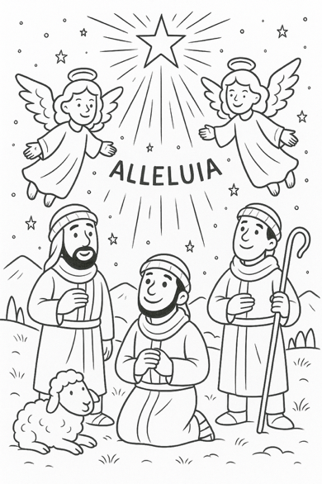
1 Silent night, holy night,  all is calm, all is bright  round yon virgin mother and child.  Holy Infant so tender and mild,  sleep in heavenly peace,  sleep in heavenly peace.  2 Silent night, holy night,  shepherds quake at the sight,  glories stream from heaven afar,  heavenly hosts sing alleluia;  Christ the Saviour is born!  Christ the Saviour is born! | 3 Silent night, holy night,  Son of God, love's pure light  radiant beams from thy holy face,  with the dawn of redeeming grace,  Jesus, Lord, at thy birth,  Jesus, Lord, at thy birth.

Christmas Message

Hark! the herald-angels sing - Hymn 160

1 Hark! the herald-angels sing  glory to the new-born King;  peace on earth and mercy mild,  God and sinners reconciled!  Joyful, all you nations, rise,  join the triumph of the skies;  with the angelic host proclaim,  ‘Christ is born in Bethlehem’:  Hark! the herald-angels sing  glory to the new-born King.  2 Christ, by highest heaven adored,  Christ, the everlasting Lord,  late in time behold him come,  offspring of a virgin’s womb:  veiled in flesh the Godhead see,  hail the incarnate Deity!  Pleased as man with us to dwell,  Jesu, our Emmanuel:  Hark! the herald-angels sing  glory to the new-born King. | 3 Hail, the heaven-born Prince of Peace!  Hail, the Sun of righteousness!  Light and life to all he brings,  risen with healing in his wings:  mild, he lays his glory by,  born that we no more may die;  born to raise each child of earth,  born to give us second birth:  Hark! the herald-angels sing  glory to the new-born King.

Prayers

O come, all ye faithful - Hymn 172

O come, all ye faithful,  joyful and triumphant,  O come ye, O come ye to Bethlehem;  come and behold him ͜  born, the King of angels;  Refrain  O come, let us adore him,  O come, let us adore him,  O come, let us adore him, Christ the Lord.  2 God of God,  Light of Light,  Lo! he abhors not the Virgin’s womb;  very God, begotten, not created: | 6 Sing, choirs of angels,  sing in exultation,  sing, all ye citizens of heaven above;  “Glory to God ͜  in the highest:”  7b Yea, Lord we bless thee,  Born for our salvation,  Jesu, to thee be glory given;  Word of the Father,  Now in flesh appearing:
Blessing

Lighting the Christmas Tree

Please join us for some festive refreshments

